Submission form
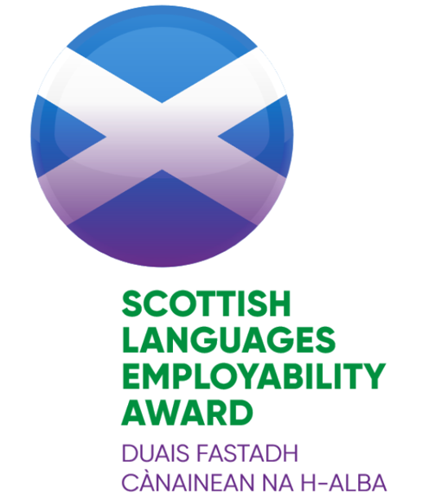

- Information
Name of school
School address and postcode
Local authority
Contact name and position in school
Contact e-mail and telephone number
School roll
Year group(s) involved in project |  | Are any of the classes involved composite?  (see FAQs of handbook) |  |  |  | Yes No
Project title
Languages incorporated
Date started |  |  |  | Date completed (if appropriate)
Please note that all projects within a submission should take place within the same academic year (see section 3 of handbook)
Has the school previously participated in the SCILT Scottish Languages Employability Award? | Yes No |  |  | If yes, please give dates, name of project and level of Award.
Partner organisation(s)
Contact(s) at partner organisation(s)

- Project Report
- Briefly give an overview of your project and activities. (approx. 300 words)

Please include the following:
- description of partner(s) involved
- planning processes
- activities undertaken
- feedback
- impact
- future plans

The Checklist for Award (see Appendix B), although not mandatory, will be useful for recording this information throughout the project and in completing this report.
- Evidence | Please submit evidence via the online form.  This should be a maximum of 6 pictures (photos/screenshots etc) – see section 5 of the handbook.

Permissions | Please indicate if you are happy for your activities to be used as exemplification by SCILT and if all relevant permissions have been obtained according to your school policies. Yes No
Signed by School | Name | Date
Signed by Partner Organisation | Name | Date
Signed off by SCILT | Name | Date

For SCILT use only

Comments and Feedback:
Level of Scottish Languages Employability Award awarded and date of award:
Bronze |  | Silver |  | Gold
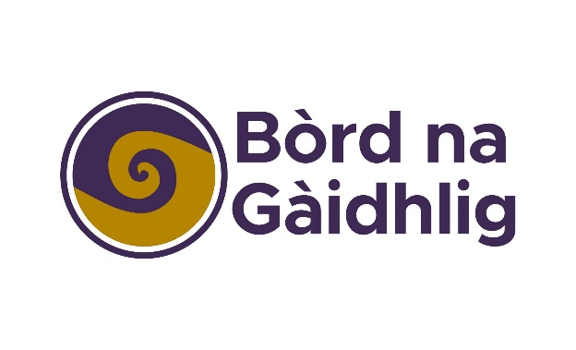
Bha Duais Fastadh Cànainean na h-Alba air a leasachadh agus ga toirt gu buil le taic-airgid o Bhòrd na Gàidhlig agus GLIF (Gaelic Language Act Implementation Funding).

The Scottish Languages Employability Award was developed and implemented with support from Bòrd na Gàidhlig and the Gaelic Language Act Implementation Fund.

